CCGP Accountability and Data Project Report
School Counselors – Creating Pathways to Student Success
Area of Focus:   Dropout/Graduation College and Career Ready  Attendance  School Climate |  |  | Graph/Legend  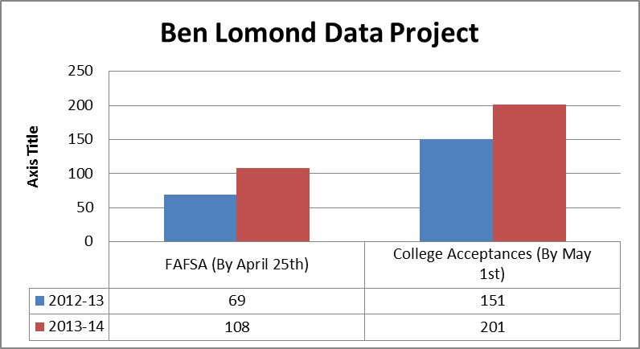
Baseline Data:
FAFSA completion project, surveys from 2013 graduating seniors, and data from colleges
Goal Statement:
Increase senior college acceptances and FAFSA completions by 15% by May 1st comparing the class of 2013 to the class of 2014.
Systemic Interventions
Individual | Individual meetings to remind students to complete applications and FAFSA. Trio and Gear Up also met with students individually to complete applications.
Group | Called students down in small groups when visiting colleges are here to help them work on finishing their college applications. These students had selected interest in the colleges on a beginning of the year survey.
Classroom | Counselors went into classes to prepare students for College Application Week, as well as reminded students about FAFSA February. The information was also given to teachers to announce.
Grade | All seniors participated in College Application Week, when they were able to apply to two colleges during advisory. They had scheduled times and locations to do their applications during that week in November. We also sent postcards to all seniors to remind them about College Application Week and FAFSA February. |  | Results/Outcome Statement  The interventions increased college acceptances by 33% and FAFSA completions by 56% by May 1st comparing the class of 2013 to the class of 2014.
School | College Application Week was a school wide initiative, in which teachers and administrators helped get information out to the seniors. We did announcements to the whole school about College Application Week as well as our six FAFSA February Nights.
Parents/Family | Parents were invited to participate and volunteer during College Application Week. We also invited all parents/families to the school to work on their FAFSA during our FAFSA Nights in February. Individual parents/families came in for appointments that could not make the FAFSA Nights.
District | The Ogden School District was very involved with College Application Week, especially Gear Up and the Ogden School Foundation. They volunteered, as well as donated money to help students pay for their applications.
Community | College Application Week was advertised to our community as a way to participate and/or volunteer at Ben Lomond. We also advertised on Facebook to our community about both College Application Week as well as our FAFSA Nights
Ogden School District School: Ben Lomond High School
Does this project supports the school’s School Improvement Plan: Yes  No
(taken from NOSCA Training Fall 2012. Vivian Lee)

